Social Media Analysis Report: Rihanna's Digital Footprint on Reddit
1. Executive Summary
This report analyses Rihanna's online presence within her dedicated Reddit community, r/Rihanna, to provide actionable insights for her public relations (PR) management. Using data collection, cleaning, and analysis methods like sentiment and topic modelling, this study measures fan engagement, identifies key discussion themes, and assesses overall sentiment for strategic communication.
Key Findings:
Analysis of 999 comments revealed a highly engaged and largely positive fanbase. Over half were positive, showing strong admiration. Many were neutral, while a small group expressed negative views, often on specific issues.
Engagement is event-driven, with big jumps in activity following new content or appearances. Tuesdays showed the highest average positive engagement, suggesting peak audience receptivity.
Key discussion areas included:
- Rihanna's Appeal & Visuals: Focus on her looks, style, and iconic status, often linked to brand campaigns (e.g., Savage X Fenty) and personal moments (e.g., pregnancy photoshoots). Authentic content drives high engagement, even if reactions are mixed.
- Strong Demand for Music: A consistent theme is the fans' deep desire for new music. Mentions of past albums and her music break frequently appear in negative comments, indicating dissatisfaction.
Implications for Public Relations:
These insights guide Rihanna's PR strategy:
- Use Authentic & Visual Content: Share real, visually strong content, especially showcasing her multifaceted persona (e.g., as a mother). This deeply connects with fans and drives interaction.
- Manage Music Demand: Acknowledge strong fan demand for new music. While a new album is ideal, interim communications (e.g., creative updates, archival content) could help reduce negative sentiment.
- Optimize Release Times: Plan content for Tuesdays to maximize positive fan reception.
- Reinforce Aesthetic Brand: Leverage her strong visual brand and appeal, particularly through Fenty ventures, as these consistently drive positive engagement.
- Proactive Monitoring: Continuously monitor sentiment, especially on music, to quickly address negative trends.
Rihanna's fanbase is vibrant and deeply connected, driven by admiration for her authenticity, iconic status, and desire for new music. Data-informed PR can effectively use these factors to enhance her brand's positive perception and engagement.
2. Data
This section details the data collection and cleaning methods used to prepare the dataset for social media analysis. Rihanna's active Reddit subreddit, r/Rihanna, was chosen as the data source due to its public content and active community, offering a rich environment for analysing fan sentiment and engagement.
2.1 Data Collection
Data was collected from r/Rihanna using the Python Reddit API Wrapper (PRAW). This allowed for systematic extraction of comments from the top 100 'hot' submissions, expanding all nested threads for comprehensive capture. The goal was to acquire a dataset of at least 200-300 unique comments for robust analysis.
The initial data collected for each comment included:
- comment_id: Unique ID for each comment.
- submission_id: ID of the Reddit post the comment belongs to.
- submission_title: Title of the Reddit post, giving immediate context.
- author: Username of the comment's author.
- comment_body: The raw text content of the comment.
- score: Net upvotes/downvotes, showing community engagement.
- created_utc: Unix timestamp of comment creation, for temporal analysis.
I initially collected 999 comments. Figure 2.1 shows an example of this raw data.
- Figure 2.1: Screenshot of Raw Data Sample

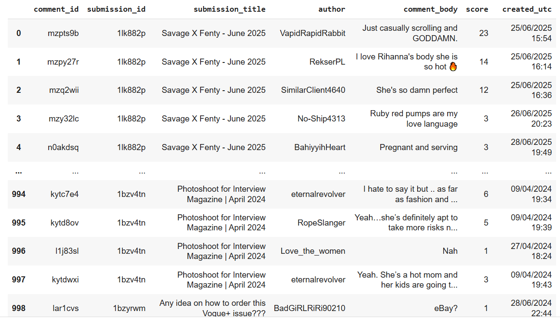
2.2 Data Pre-processing
Raw social media data often contains noise and inconsistencies that can hinder analysis. Thus, a series of pre-processing steps were applied to the comment_body column to ensure the data was clean, standardized, and suitable for analysis. This pipeline aimed to reduce complexity and remove irrelevant information.
2.2.1 Handling Missing and Empty Values
Initial pre-processing involved removing missing (NaN) and empty comment entries from the comment_body column. Comments consisting only of whitespace were also removed. This ensured only entries with actual textual content remained, preventing errors and improving data quality.
- Figure 2.2: Screenshot of Data Sample After Handling Missing and Empty Values
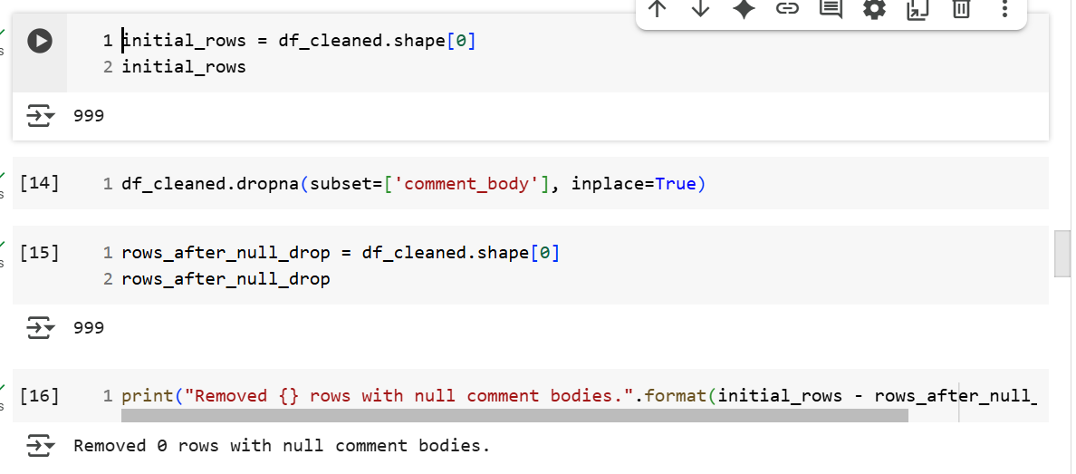
2.2.2 Case Normalization (Lowercasing)
To ensure consistency, all text in comment_body was converted to lowercase. This prevents variations in capitalization (e.g., "Rihanna," "rihanna") from being treated as different words, crucial for accurate word counts and consistent analysis.
- Figure 2.3: Screenshot of Data Sample After Lowercasing
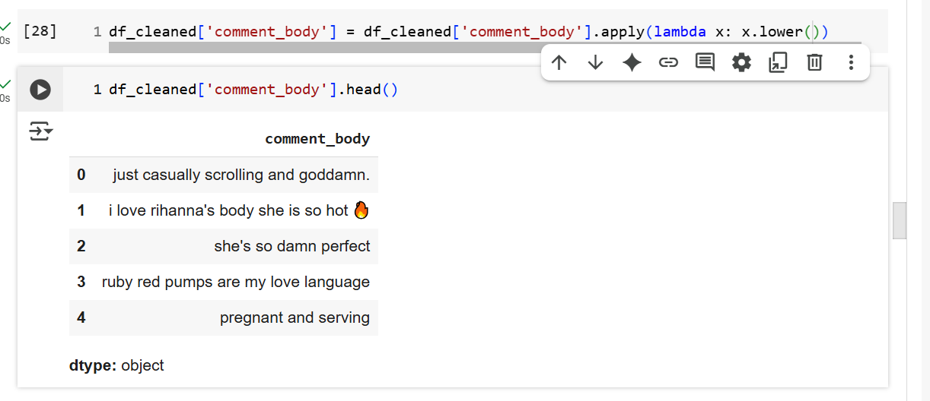
2.2.3 Removing URLs, Mentions, and Special Formatting
Irrelevant elements like URLs, user mentions (u/username), subreddit mentions (r/subreddit), and Markdown formatting were removed using regular expressions. This reduced noise and focused content on meaningful words. A check of the raw data showed no such elements were present, so this step made no changes to the dataset.
2.2.4 Removing Punctuation, Numbers, and Emojis
Next, all punctuation, numbers, and emojis were removed from comment_body. These elements typically do not add semantic meaning for text analysis and can introduce noise. Their removal reduced vocabulary size and focused on core textual content.
- Figure 2.4: Screenshot of Data Sample Before Removing Punctuation, Numbers, and Emojis
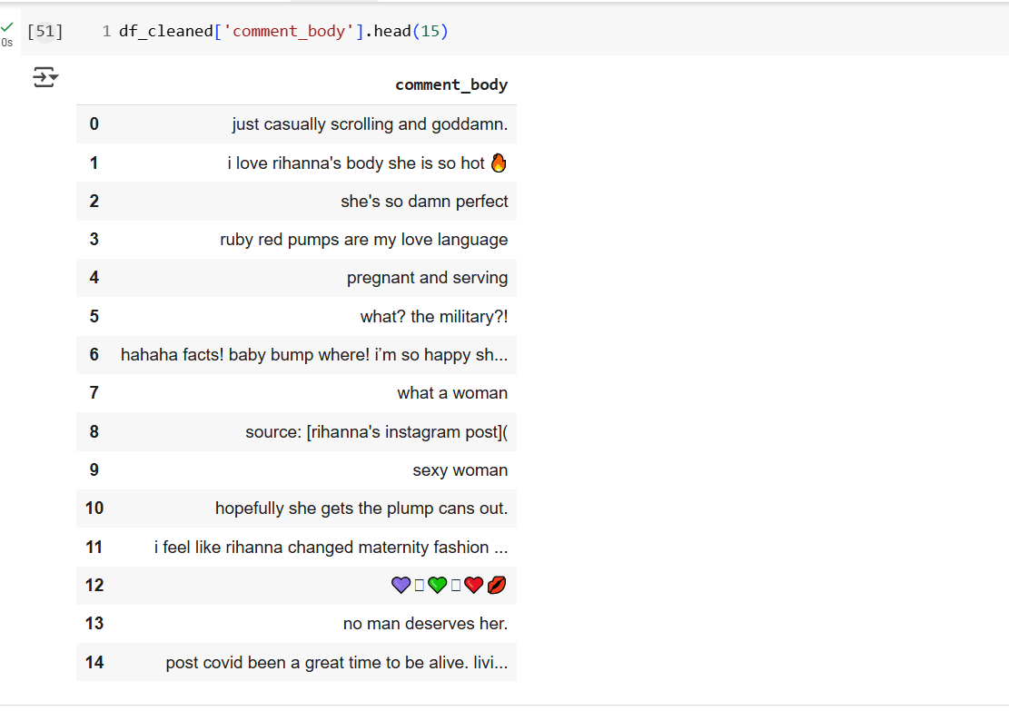
- Figure 2.5: Screenshot of Data Sample After Removing Punctuation, Numbers, and Emojis
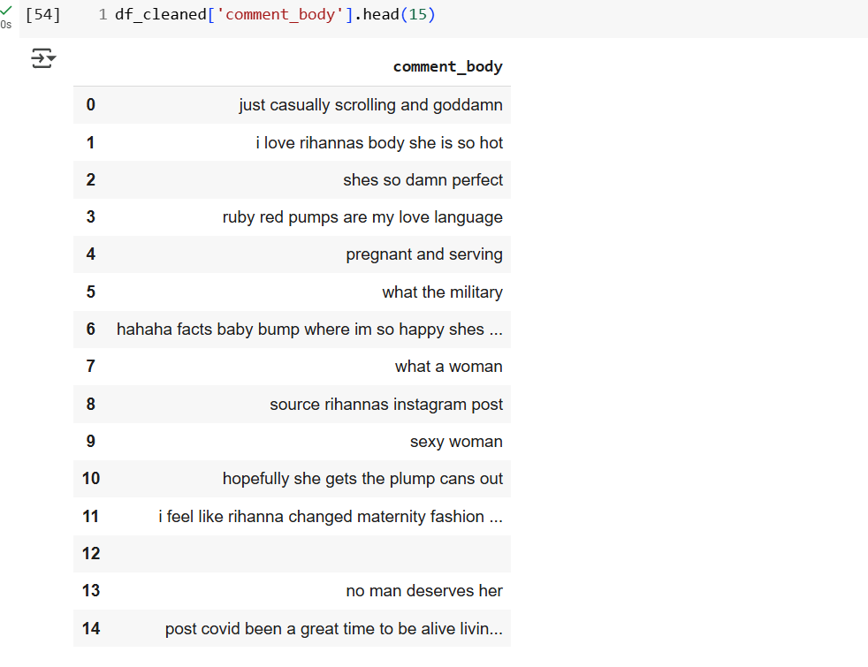
2.2.5 Removing Post-Processing Empty Strings
After removing punctuation, numbers, and emojis, some comments became empty. To maintain data quality, any rows where comment_body became an empty string were removed. This ensures only meaningful text is carried forward.
- Figure 2.6: Screenshot of Data Sample After Removing Post-Processing Empty Strings
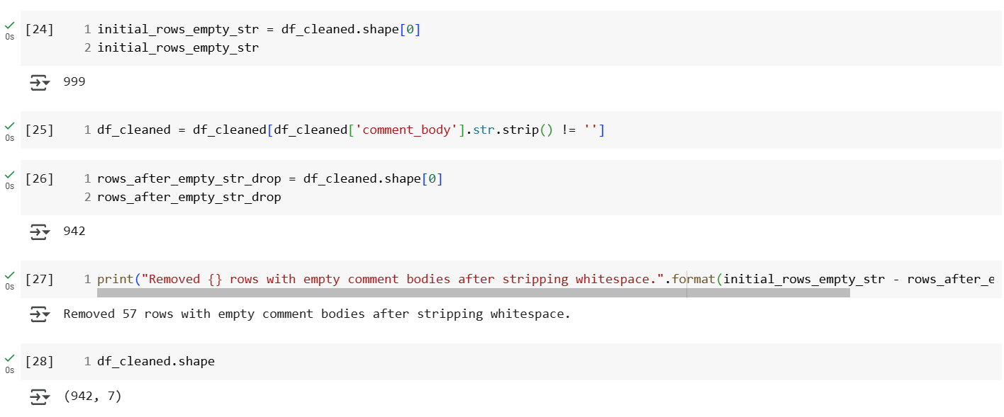
2.2.6 Tokenization, Stop Word Removal, and Lemmatization
The final pre-processing stage transformed cleaned text for advanced analysis. This included: 1. Tokenization: Breaking comment_body into individual words ("tokens").
2. Stop Word Removal: Removing common, low-meaning words (e.g., "the," "is") to focus on significant terms.
3. Lemmatization: Reducing words to their base form (e.g., "running" to "run"). Lemmatization ensures actual dictionary terms, improving interpretability. These steps collectively ensured the comment_body data was normalized and optimized for analysis, creating the processed_comment_body column.
- Figure 2.7: Screenshot of Data Sample After Tokenization, Stop Word Removal, and Lemmatization
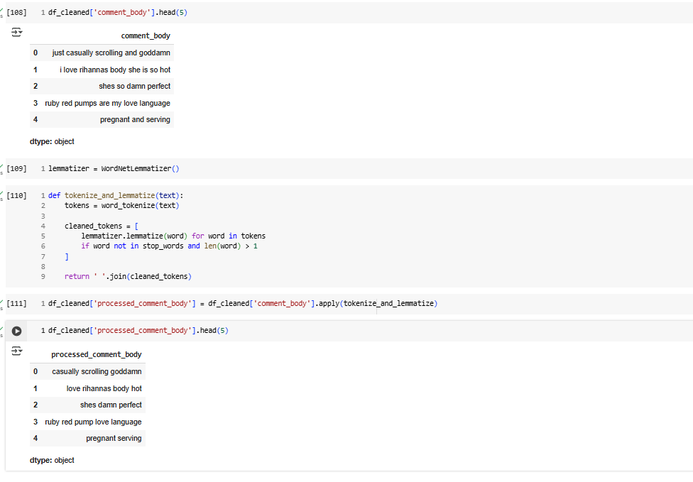
3. Exploratory Analysis
Exploratory Data Analysis (EDA) was performed on the cleaned Rihanna subreddit comments to understand community discussion and engagement. This section presents five visualizations covering word frequencies, comment score distribution, and temporal activity.
3.1 Top Word Frequencies
Word frequency analysis revealed prominent themes. After cleaning, top words included "rihanna" and "riri," showing her central role. Terms like "music," "album," and "song" highlight strong interest in her creative work and fans' anticipation for new releases. Positive words such as "love," "great," "beautiful," "gorgeous," "sexy," and "body" indicate a highly appreciative fanbase, often focusing on her physical attractiveness and style, which links to her Savage X Fenty brand. This suggests strong fan loyalty and diverse engagement points, alongside a clear demand for new music.
- Figure 3.1: Top 30 Most Frequent Words in Rihanna Subreddit Comments
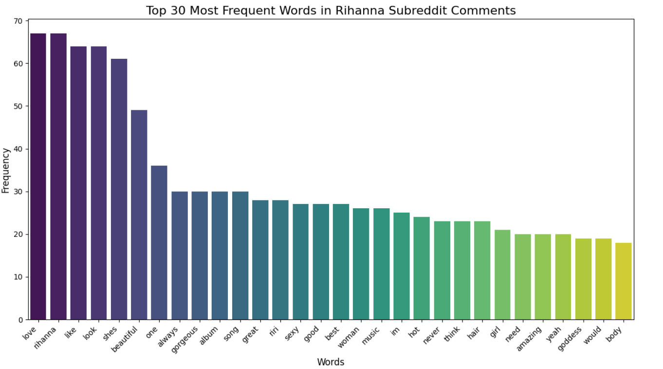
3.2 Distribution of Comment Scores
Comment scores on Reddit show community engagement. Figure 3.2 displays a highly skewed distribution, with a peak near 0 or 1. This indicates most comments receive low engagement, often remaining neutral. However, a long tail into positive scores shows many comments achieve high approval, representing well-received content. A shorter negative tail indicates less frequent and less extreme downvotes. This pattern suggests a generally positive and supportive environment.

- Figure 3.2: Distribution of Comment Scores
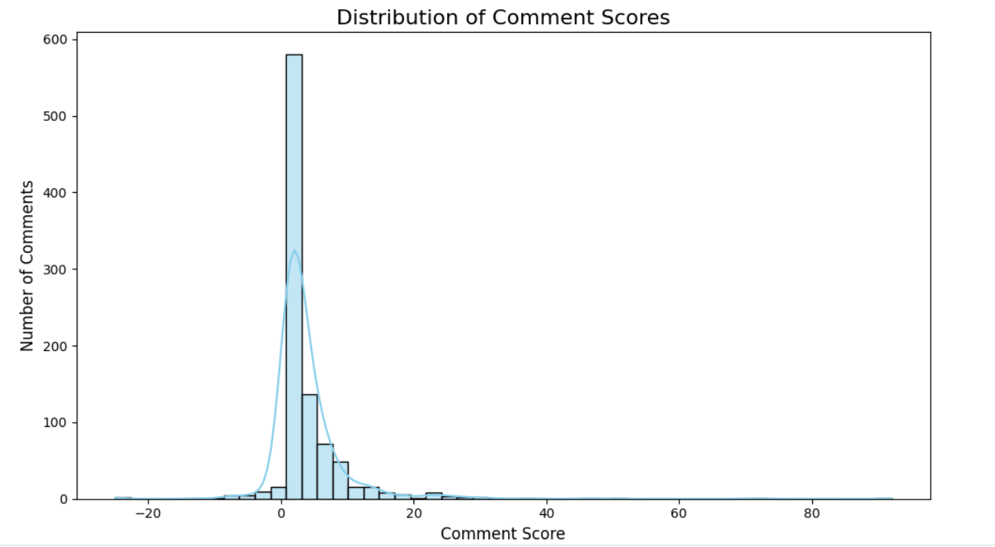
3.3 Most Engaged Comments by Submission Context (Score)
Analyzing top-scoring comments reveals content and topics that most engage the r/Rihanna community.
- Figure 3.3: Most Engaged Comments by Submission Context (Score)
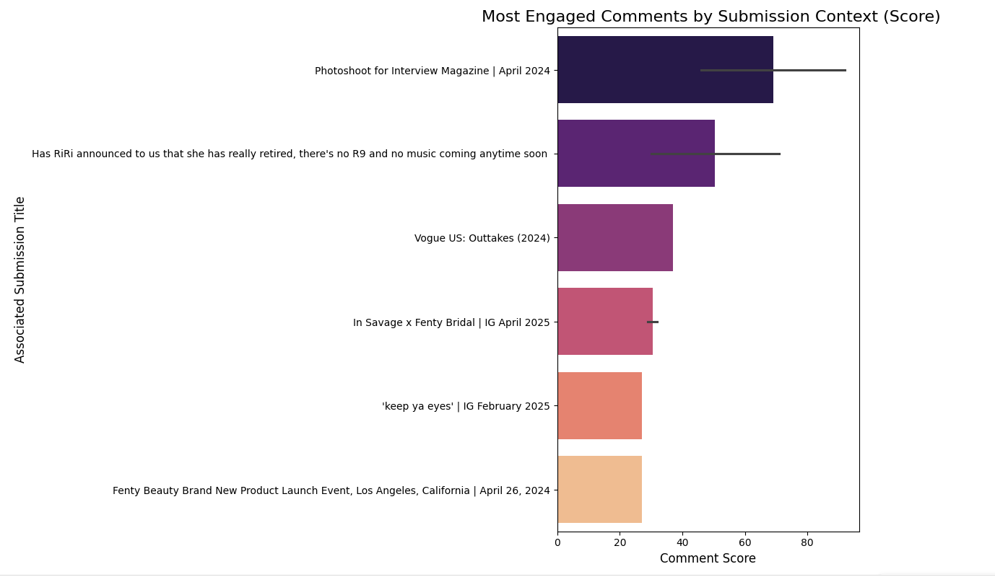
Interpretation: Figure 3.3 highlights the top 10 most engaged comments, contextualized by their Reddit post titles. Key themes driving high positive interaction include:
- Authenticity and Realness: High-scoring comments often relate to Rihanna's authenticity, particularly as a mother. The "Interview Magazine" photoshoot, with its unconventional portrayal, resonated deeply for its "realness," sparking both strong appreciation and polarized reactions. This highlights how candid content can foster deep connection but also divide opinion.
- Strong Demand for Music: The second most engaged post directly addresses the strong desire for new music ("R9"), confirming music discussions as a major engagement driver.
- Iconic Looks and Big Life Moments: Iconic photoshoots and personal milestones (e.g., "Vogue US: Outtakes," "Savage x Fenty Bridal") also drive high engagement. Content showcasing her bold, unapologetic brand and captivating visuals is enthusiastically embraced.
- Appreciation for Looks and Brand Ads: Comments on her beauty and fashion ventures also show high engagement. Visual content linking her physical appeal to product promotion (e.g., hair products in lingerie, Fenty Beauty launch) confirms her aesthetic choices are highly valued.
In summary, highly engaging content revolves around Rihanna's authenticity, anticipated music, iconic visual presence (personal milestones, brand campaigns), and overall appeal. For a PR, content showing her genuine self, addressing music demand, and leveraging her strong visual brand (including Savage X Fenty) is most effective for positive interaction, though some approaches may divide opinion.
3.4 Daily Comment Activity Over Time
Daily comment activity (Figure 3.4) shows an event-driven pattern, with significant spikes following major content releases. A prominent surge in late February 2025, likely tied to the "keep ya eyes" video (Rihanna promoting hair products in lingerie), indicates visually striking and branded content has a strong immediate impact. While a core community maintains baseline activity, major external stimuli are crucial for widespread interaction. This highlights the importance of strategic content timing for PR to generate buzz.
- Figure 3.4: Daily Comment Activity Over Time
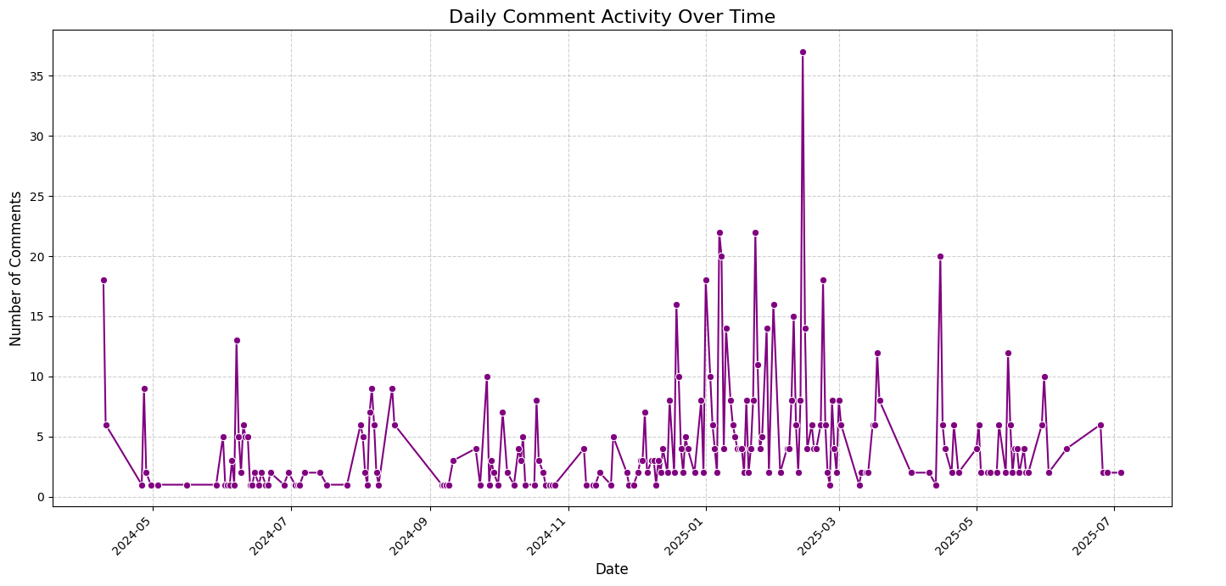
3.5 Average Comment Score by Day of Week
Average comment scores by day (Figure 3.5) show Tuesday as having significantly higher average engagement, indicating peak audience receptivity or strategic content releases. Scores remain moderately positive from Wednesday to Saturday. Sunday shows the lowest average score, potentially influenced by broader social factors like rest or religious observance, leading to different online interaction patterns or reduced receptivity to certain content (e.g., less "PG" material). Mondays show a gradual increase. For PR, Tuesdays are ideal for maximizing positive reception, allowing for strategic content timing.
- Figure 3.5: Average Comment Score by Day of Week
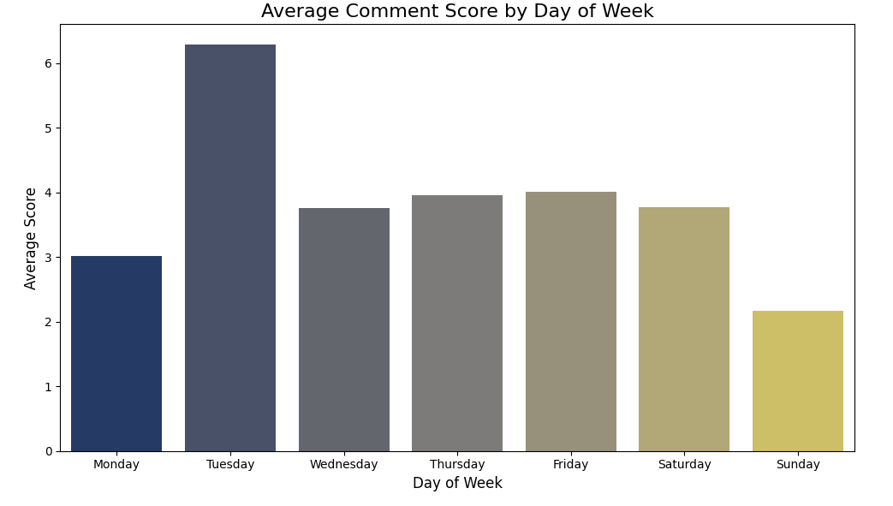
4. Text Mining and Sentiment Analysis
This section uses sentiment analysis and topic modelling to gain deeper insights into the emotional tone and recurring themes within r/Rihanna comments.
4.1 Sentiment Analysis
Sentiment analysis using VADER classified comments as Positive (≥0.05), Negative (≤−0.05), or Neutral (between -0.05 and 0.05). Figure 4.1 shows a predominantly positive sentiment (51.0%), aligning with frequent positive words. A significant portion (38.1%) was Neutral, consistent with comments having low scores. Only 10.9% were Negative, confirming a vocal minority and specific criticisms. Overall, the sentiment reveals a largely positive and active community with balanced discussion.

- Figure 4.1: Overall Sentiment Distribution in Rihanna Subreddit Comments
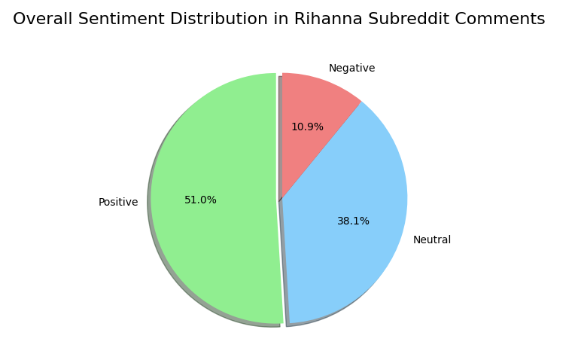
4.2 Sentiment Over Time
Average daily sentiment (Figure 4.2) generally remains positive to neutral, consistent with overall sentiment. A notable dip occurred in late June/early July 2024, potentially due to reduced discussion intensity or less engaging content, rather than a specific negative event. This dynamic pattern highlights the need for PR to continuously monitor sentiment over time and investigate dips to maintain a positive brand image.
- Figure 4.2: Average Daily Sentiment Over Time
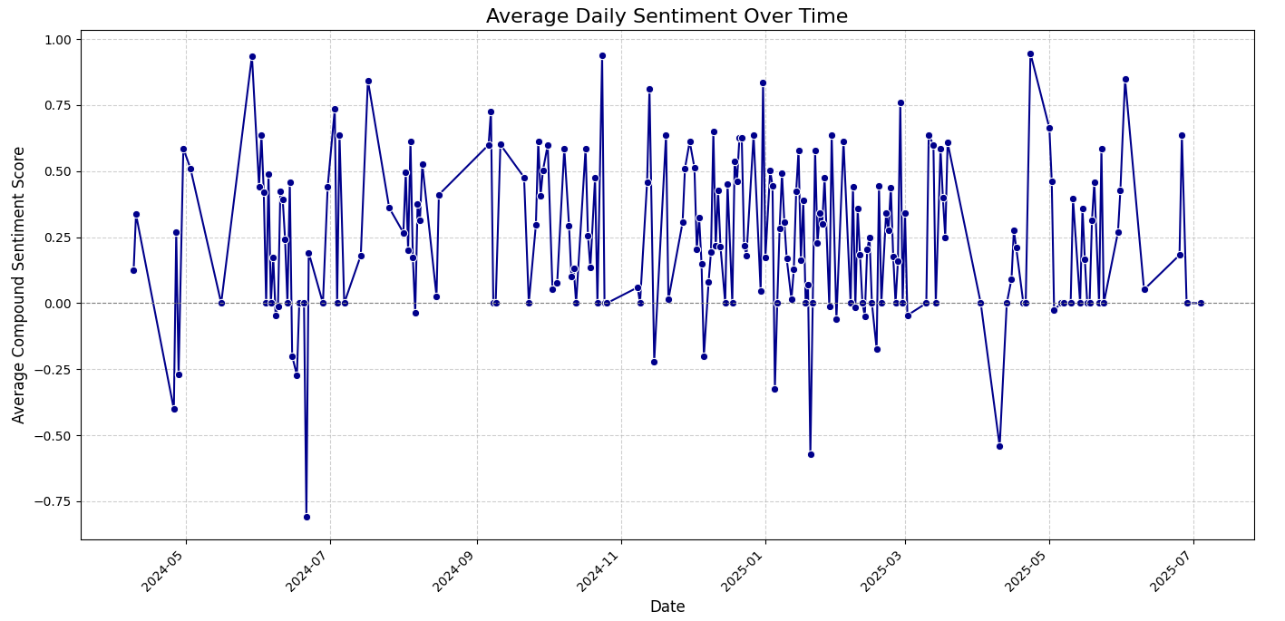
4.3 Top Words in Positive and Negative Comments
Analysis of top words in positive and negative comments (Figures 4.3 and 4.4) reveals specific emotional drivers. In positive comments (Figure 4.3), terms like "beautiful," "gorgeous," "sexy," and "look" confirm strong positive sentiment tied to Rihanna's appearance. "Sing" and "song" also indicate continued positive engagement around her music. For negative comments (Figure 4.4), "song" with "miss," "era," "anti," and "loud" (album titles) strongly suggest dissatisfaction stems from her music hiatus. Direct negative terms like "damn" and "bad," plus criticisms of "outfit" or "look," highlight specific pain points. Despite overall admiration, the lack of new music is a consistent issue.
- Figure 4.3: Top 15 Words in Positive Comments (Excluding Common Terms)
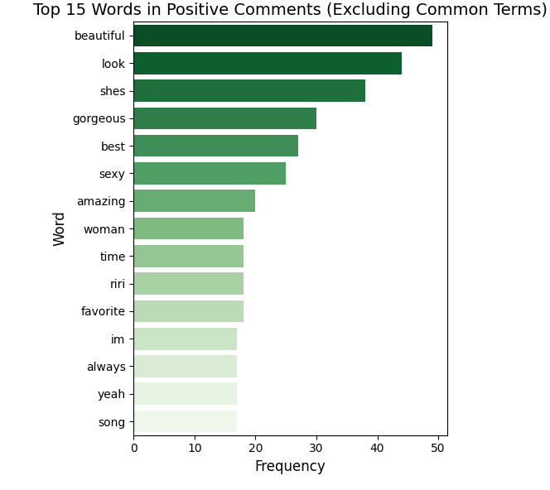
- Figure 4.4: Top 15 Words in Negative Comments (Excluding Common Terms)
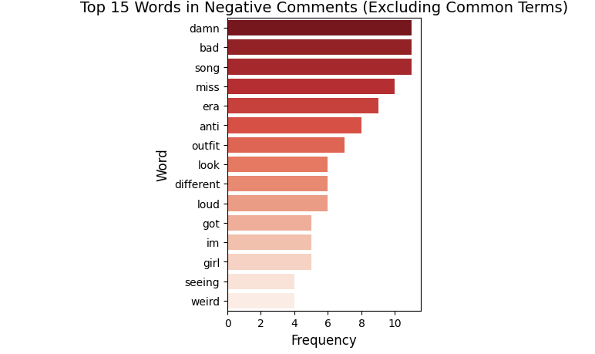
4.4 Topic Modelling
Topic Modelling (LDA) identified 5 hidden themes within r/Rihanna comments by finding words that frequently appear together.
4.4.1 Distribution of Dominant Topics Across Comments
Figure 4.5 shows a relatively balanced distribution of comments across the 5 topics, indicating diverse discussions. Topic 4 and Topic 1 are slightly more common. Each topic's theme was inferred from its top words:
- Topic 0 (General Appeal & Social Media): Focuses on Rihanna's overall appeal, Instagram posts, and informal positive reactions (e.g., "hot," "perfect," "instagram").
- Topic 1 (Physical Appearance & Style): Heavily features her looks, style, and hair (e.g., "look," "gorgeous," "hair").
- Topic 2 (Attractiveness & Iconic Status): Centers on her allure, power, and iconic image (e.g., "beautiful," "sexy," "queen," "body").
- Topic 3 (Music Hiatus & Career): Addresses fan desire for new music, past albums, and how her personal life (e.g., "pregnant") intersects with career expectations (e.g., "song," "album," "anti," "era"). This captures longing and frustration.
- Topic 4 (General Adoration & Empowerment): Expresses broad positive sentiment for Rihanna as a powerful figure (e.g., "love," "great," "goddess," "woman").
- Figure 4.5: Distribution of Dominant Topics Across Comments
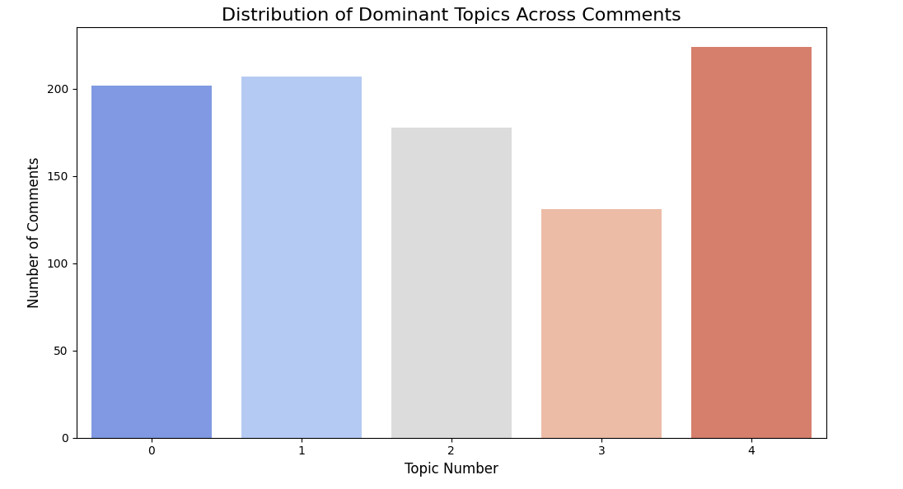
4.4.2 Top Words Per Topic
Figure 4.6 visually confirms the themes of each topic. Topic 0 highlights general appeal and social media presence (e.g., "hot," "instagram"). Topic 1 focuses on physical appearance and style, particularly hair (e.g., "look," "gorgeous," "hair"). Topic 2 emphasizes attractiveness and iconic status (e.g., "beautiful," "sexy," "queen"). Topic 3 clearly shows discussions about her music hiatus and career, including album references and pregnancy (e.g., "song," "album," "anti," "pregnant"). Topic 4 represents general adoration and female empowerment (e.g., "love," "goddess," "woman"). These visuals provide strong evidence for the distinct thematic clusters in the comments.
- Figure 4.6: Top Words Per Topic (Multiple Bar Charts)
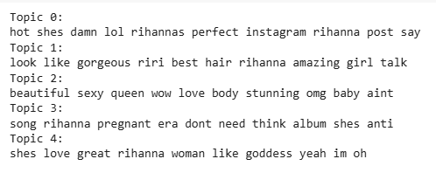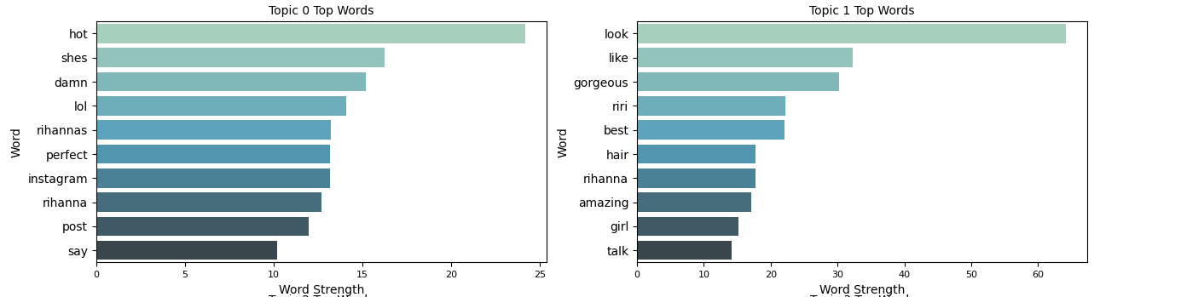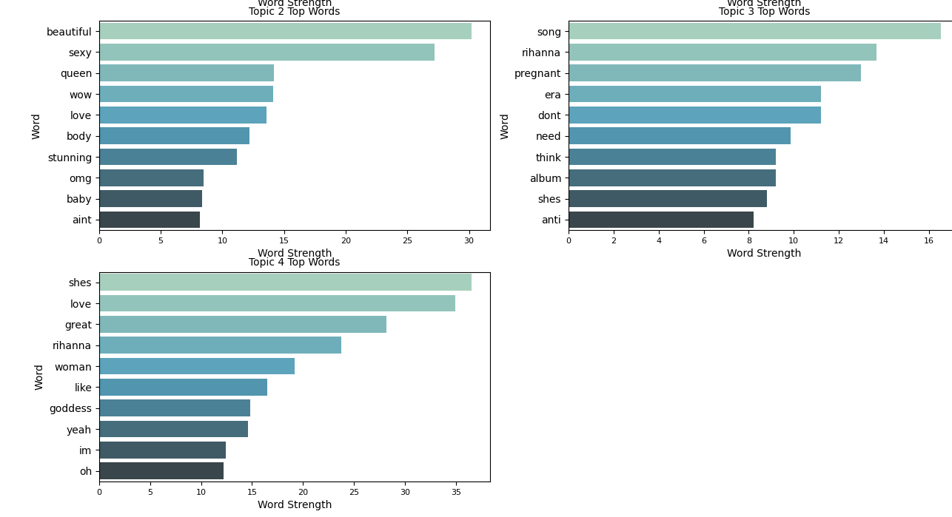

5. Conclusion and Reflection
This report aimed to analyse Rihanna's online presence on her Reddit subreddit, r/Rihanna. I used data collection, cleaning, exploratory analysis, text mining, and sentiment analysis. The findings offer useful insights for a public relations (PR) company managing her brand, helping them make better decisions for content and fan engagement.
5.1 Key Findings
Key findings include:
Predominantly Positive Sentiment: Over half of comments were positive, showing strong fan appreciation, with many neutral and a small negative minority.
Engagement from Authenticity & Visuals: Content showing Rihanna's authentic self (e.g., as a mother) and iconic visuals drives high engagement, sometimes with mixed reactions.
Strong Desire for Music: A consistent theme is fans' deep wish for new music, with negative comments often linking to her music hiatus and past albums.
Event-Driven Activity & Optimal Timing: Subreddit activity spikes with new content. Tuesdays show highest average positive engagement, while Sundays are lower.
Core Discussion Topics: Five themes were identified: general appeal/social media, physical appearance/style, attractiveness/iconic status, music career discussions (including hiatus), and general adoration/female empowerment.
5.2 Implications for Public Relations
For PR:
Use Authentic & Visual Content: Share real, visually strong content, especially showcasing her multifaceted persona.
Address Music Demand: Acknowledge strong fan demand for new music; interim communications can help.
Optimize Release Times: Tuesdays are ideal for maximizing positive fan response; Sundays may be less effective.
Reinforce Aesthetic Brand: Leverage her strong visual brand and appeal, particularly via Fenty, which consistently drives positive engagement.
Proactive Monitoring: Continuously monitor sentiment, especially on music, to quickly address negative trends.
5.3 Reflection on Methodology and Limitations
Limitations include:
Specific Data Source: Findings from Reddit may not generalize to all platforms (e.g., Twitter, Instagram).
Timeframe: Analysis covers a specific period; trends can change rapidly.
Sentiment Analysis Nuances: VADER may struggle with sarcasm or subtle language, requiring human validation.
Topic Model Interpretation: The chosen number of topics (5) and word list interpretation involve subjective judgment.
Data Volume: While 999 comments is a good sample, more data could yield deeper insights.
No Demographics: Lack of user demographics limits audience segmentation.
5.4 Future Work
Future work could involve:
Cross-Platform Analysis: Collecting data from other platforms (e.g., Twitter, Instagram) for a holistic view.
Advanced NLP Models: Using deep learning models (e.g., BERT) for improved sentiment or topic analysis.
Deep Qualitative Study: Analysing polarizing comments for deeper contextual understanding.
Long-Term Study: Collecting data over an extended period to observe trends and impact of career milestones.
Content-Specific Analysis: Categorizing and analysing sentiment for different content types (e.g., music vs. Fenty promotions).

